InsightForge: AI-Powered Business Intelligence Assistant
By Janine White
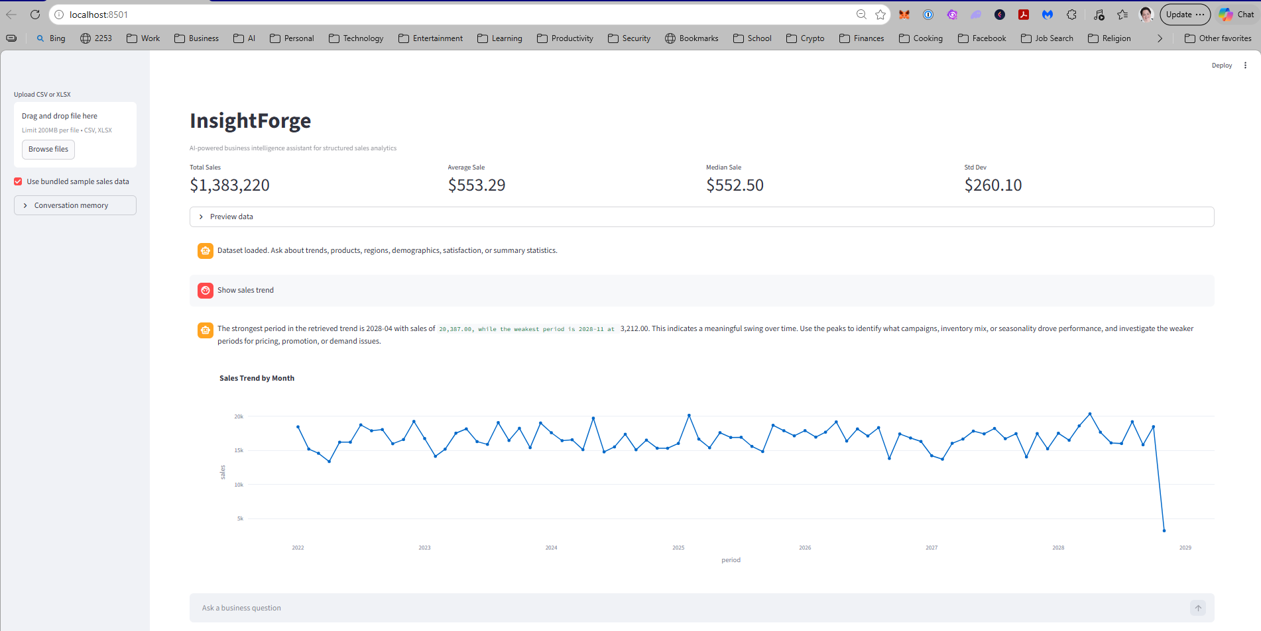

1. Introduction
InsightForge is an AI-powered business intelligence assistant designed to analyze structured sales data and provide actionable insights through a conversational interface. The system integrates data analytics, retrieval-augmented generation (RAG), and optional large language model (LLM) capabilities to support decision-making in business contexts.
The objective of this project is to develop an agentic AI system that can interpret user queries, retrieve relevant analytical outputs, and generate meaningful business insights. The application is built using Streamlit and operates locally on a Windows 11 environment.

Examples of Supported Analyses

Trend Chart
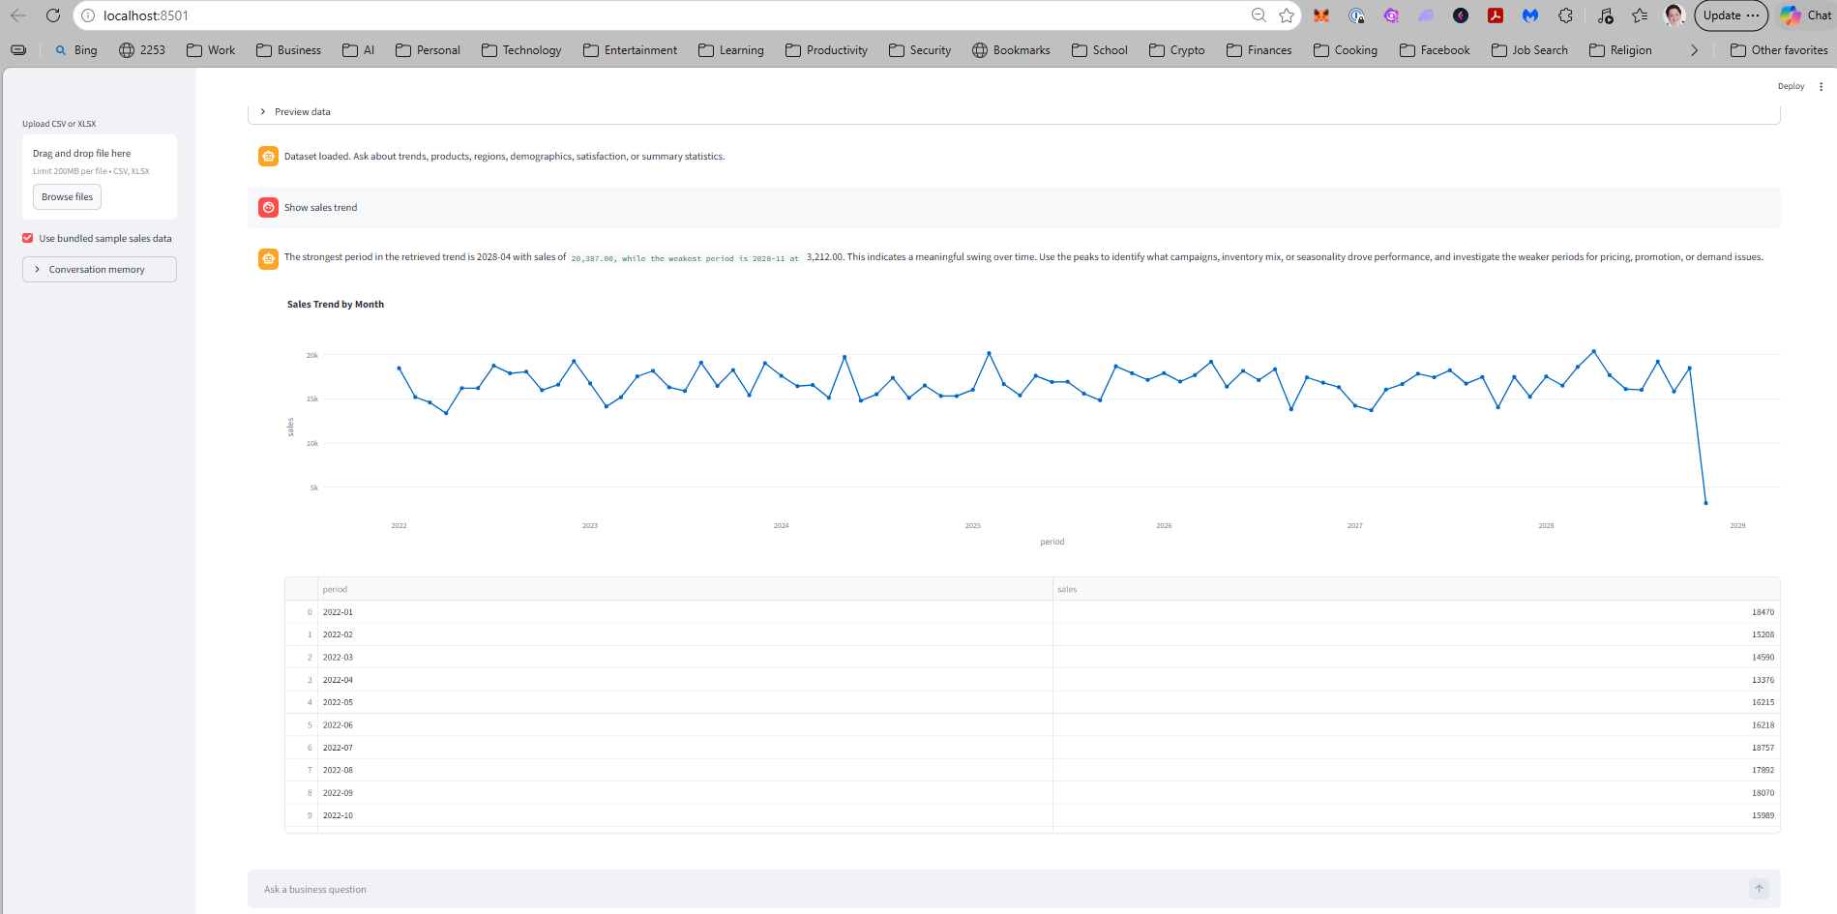

Product Performance
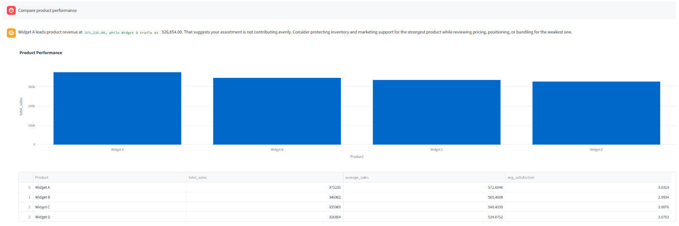

Regional Analysis
Without API Key
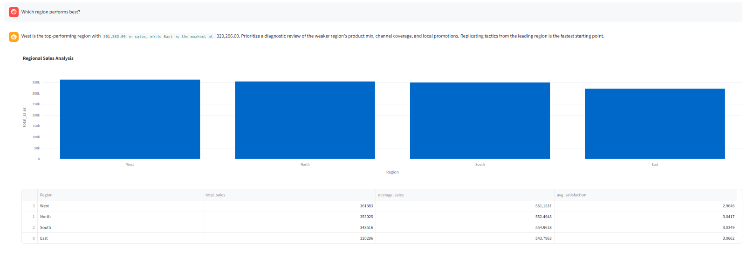
With API Key
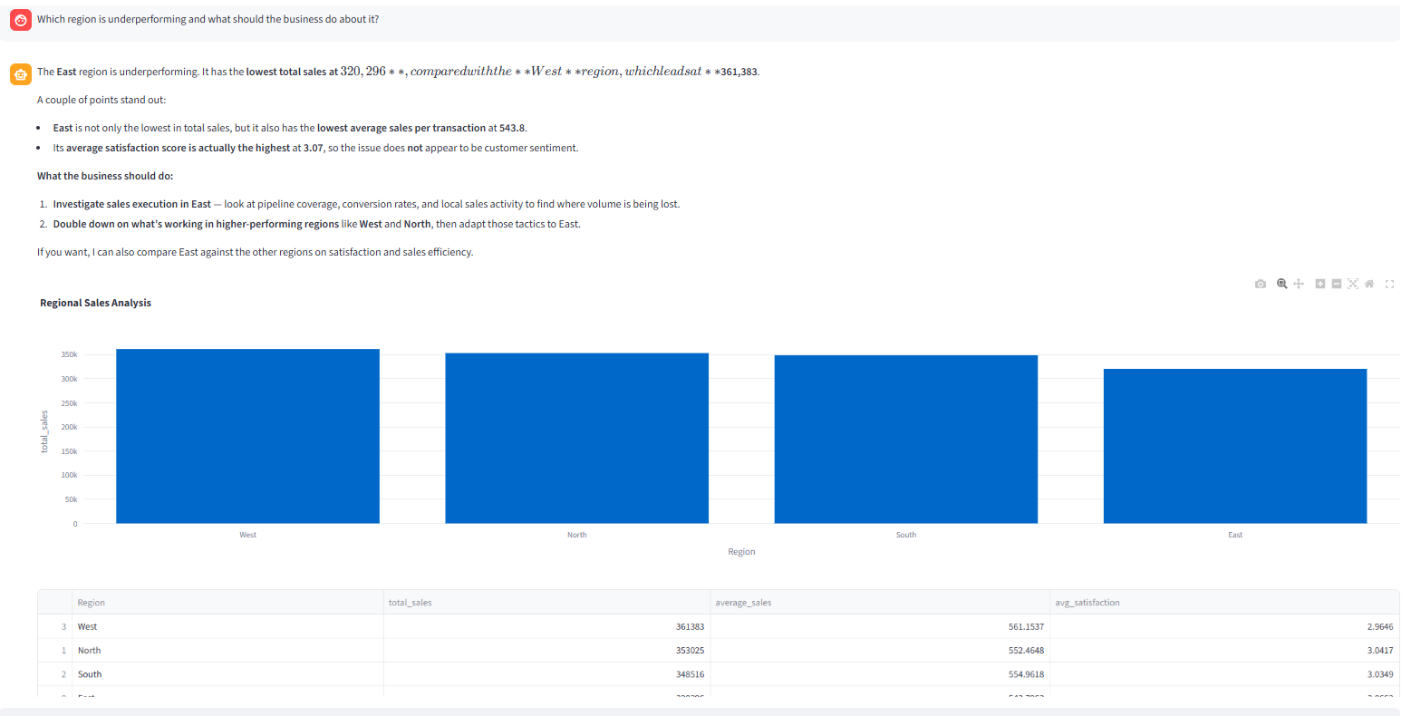

Segmentation
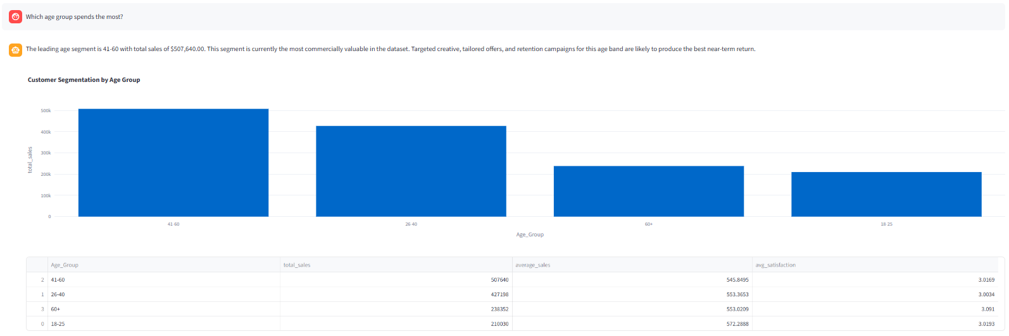

2. Problem Statement
Organizations often struggle to extract meaningful insights from structured data due to limitations in technical expertise or tool complexity. Traditional BI tools require manual querying and interpretation, which can be time-consuming and inaccessible to non-technical users.
InsightForge addresses this gap by enabling natural language interaction with structured datasets, allowing users to ask business questions and receive data-driven insights without needing advanced analytical skills.

3. System Architecture
The system follows a modular architecture consisting of the following components:
- Data Layer: Handles ingestion of structured datasets using pandas.
- Metric Engine: Computes key performance indicators (KPIs) such as total sales, averages, trends, and segmentation.
- Retriever: Maps user queries to relevant analytical functions (structured RAG).
- Agent Layer: Generates responses using either rule-based logic or OpenAI LLM.
- Visualization Layer: Produces charts using Plotly.
- Memory & Logging: Maintains session context and logs interactions in SQLite.
This architecture enables scalability, modularity, and clear separation of concerns.

4. Methodology
The system uses a structured retrieval approach instead of traditional vector-based RAG. User queries are parsed to determine intent, which is then mapped to analytical functions. The retrieved data is summarized and passed to an LLM (if available) for natural language explanation.
Prompt chaining is used to guide the LLM in generating insights, ensuring responses remain grounded in the retrieved data. Session memory enables follow-up queries and contextual continuity.

5. Implementation
The application is implemented in Python and consists of multiple modules:
- data_loader.py: Loads and validates dataset
- metric_engine.py: Performs analytical computations
- retriever.py: Routes queries to analysis functions
- agent.py: Generates responses (LLM or fallback)
- charts.py: Creates visualizations
- evaluator.py: Runs evaluation tests
The frontend is built using Streamlit, providing an interactive chat interface and visualization display.

6. Evaluation
The system includes an evaluation pipeline that tests predefined queries and logs results. The evaluation assesses:
- Accuracy of retrieved metrics
- Relevance of responses
- Completeness of insights
Optional integration with LangChain's QAEvalChain enables automated grading of responses.
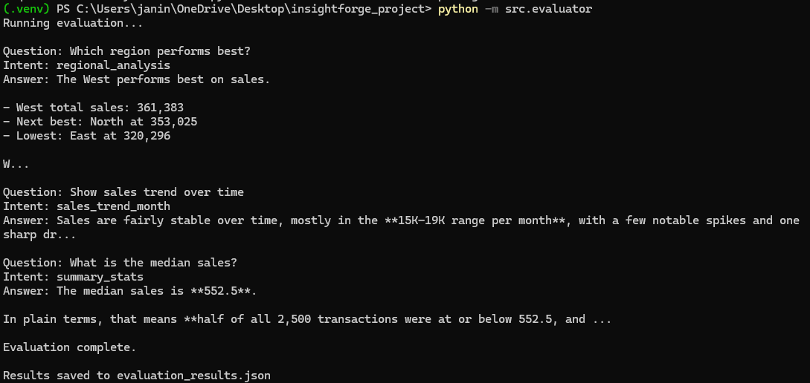

7. Results
InsightForge successfully demonstrates:
- Accurate retrieval of business metrics
- Effective visualization of trends and comparisons
- Natural language explanations of analytical results
- Robust performance in handling multiple query types
The system provides meaningful business recommendations based on data analysis.

8. Conclusion
InsightForge meets the objectives of an AI-powered BI assistant by combining structured analytics with conversational AI. The system enhances accessibility to data insights and demonstrates the potential of agentic AI in business intelligence applications.
Future improvements include advanced anomaly detection, deeper LLM integration, and enhanced evaluation metrics.

